Submitted To
Dr. Ashraf Uddin
Assistant Professor, CS, AIUB
Heart Disease Risk Assessment Dataset
Group: G-05, Section: C

AI Usage Declaration
We, the undersigned students, hereby declare that this project and its accompanying report/code have been primarily prepared by our group.
We acknowledge that the use of Artificial Intelligence (AI) tools such as ChatGPT, GitHub Copilot, Grammarly, or similar systems was permitted only to assist in learning, idea generation, code debugging, or language improvement.
We further declare that:
- We have clearly mentioned below the specific purposes for which AI tools were used (if any).
- The core design, implementation, analysis, and conclusions are our own original work.
- We collectively take full academic responsibility for the content of this submission.
AI Usage Details:
☐ No AI tools were used.
☐ AI tools were used for the following purposes (please specify clearly):

 | Name | Student ID | Signature with Date
1. |  | 22-48203-2 | 25/11/2025
  MD. HUSNE JAMAN SHAHED
2. | MAHABUB HASSAN SHAZID | 22-46512-1 | 25/11/2025
3. | MD. ASHIQUR RAHMAN BISHAL | 22-47883-2 | 25/11/2025
4. |  | 22-47950-2 | 25/11/2025
  MD. JANNATUL NAYEEM

Table of Contents
Part A: Data Understanding: 4
1. Dataset Creation: 4
This project uses a Heart Disease Risk Assessment Dataset, which contains individual medical records along with key cardiovascular indicators. Although the file was uploaded manually rather than taken from Kaggle, it follows the same structure and characteristics as common open-source heart disease datasets. 4
Each row in the dataset represents one patient, and the attributes capture essential information such as age, cholesterol levels, ECG results, and other factors that are often considered when assessing heart-related conditions. 4
Original Dataset Summary: 5
B. Data Exploration & Visualization 5
1.Data Exploration: 5
3.Possible Outliers: 9
Part C: Data Preprocessing: 10
1.Handling Missing Values: 10
2.Handling Outliers: Outlier Identification 10
3. Data Conversion: 11
4.Data Transformation: 11
5.Data Exploration: 12
Summary of Findings and Conclusion 13

List of Table and Figures
Table 1: Write the table caption Error! Bookmark not defined.

Fig. 1: Write a proper caption Error! Bookmark not defined.

Heart Disease Risk Assessment Dataset

Part A: Data Understanding:

1. Dataset Creation:

This project uses a Heart Disease Risk Assessment Dataset, which contains individual medical records along with key cardiovascular indicators. Although the file was uploaded manually rather than taken from Kaggle, it follows the same structure and characteristics as common open-source heart disease datasets.

Each row in the dataset represents one patient, and the attributes capture essential information such as age, cholesterol levels, ECG results, and other factors that are often considered when assessing heart-related conditions.
Dataset Link:
https://drive.google.com/file/d/1zJ88jw1ktRW6KuF9zhaFAQNH6zfcGtC6/view?usp=drive_link

The dataset includes the following features:
- Age - Patient age
- Sex - Male (M) or Female (F)
- Chest Pain Type -One of ATA, NAP, ASY, TA
- Resting BP -Resting blood pressure (mmHg)
- Cholesterol - Serum cholesterol in mg/dL
- Fasting BS -Fasting blood sugar indicator (0/1)
- Resting ECG -ECG results (Normal, ST, LVH)
- Max HR - Maximum heart rate achieved
- Exercise Angina - Whether exercise-induced angina is present
- Old peak - ST depression value
- ST Slope -Shape of the ST segment (Up, Flat, Down)
- Heart Disease - Target class (1 = disease, 0 = healthy)

Original Dataset Summary:
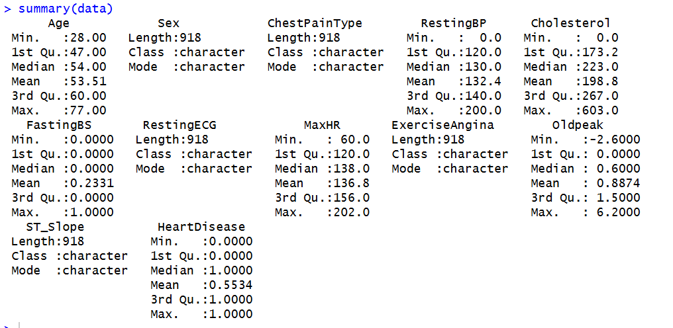
Fig-1: Original Dataset Summary

B. Data Exploration & Visualization

1.Data Exploration:
Univariate Analysis:
Histograms: Histograms were created for numerical feature to explore their ranges and patterns.
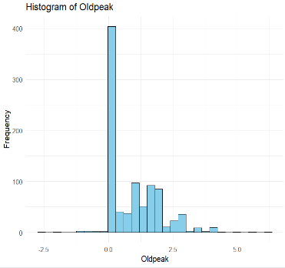
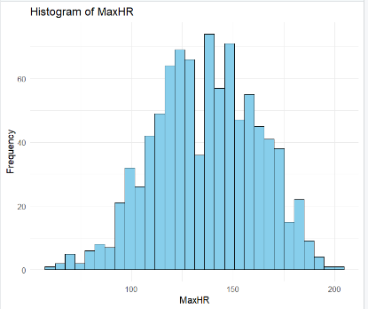
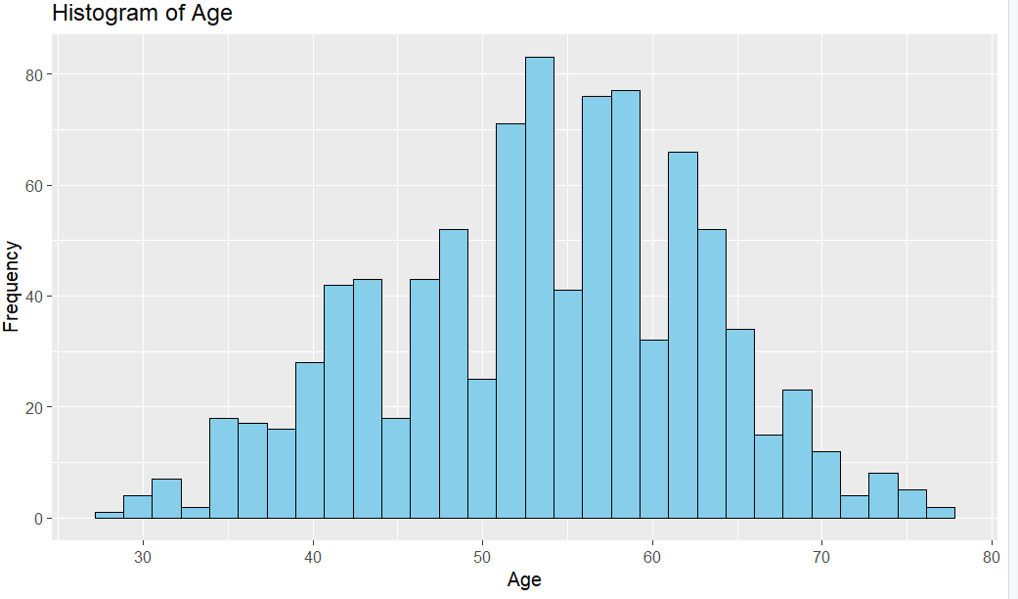Fig-2: Histograms

Box Plots:
Boxplots made it easy to pinpoint outliers and variation across numeric features. Cholesterol had the most noticeable outlier values.
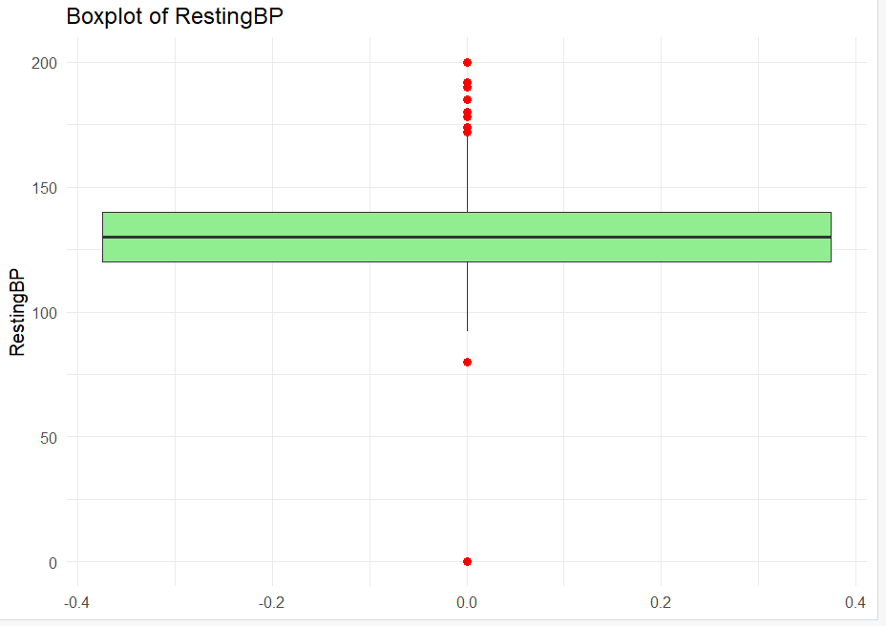
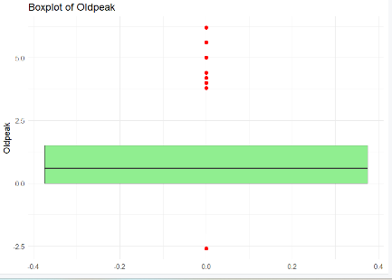
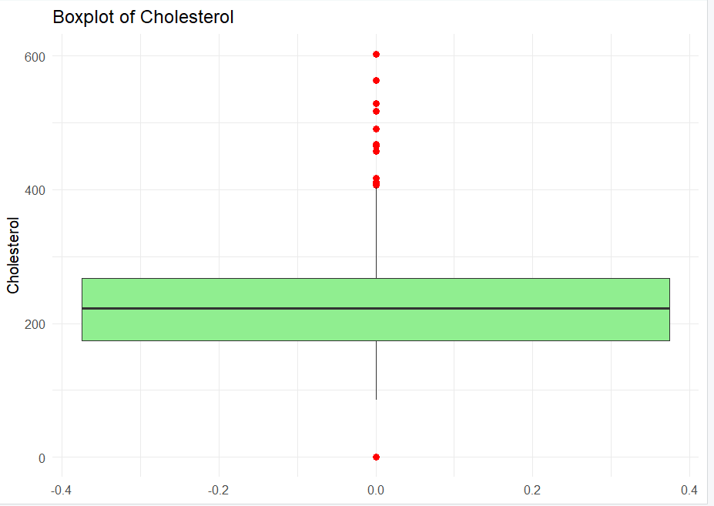
Fig-3: Boxplots
Bar Charts:
Bar plots were generated for categorical features. They showed, for example:
- More males in the dataset
- ASY as the most common chest pain type
- Most ECG results being “Normal”
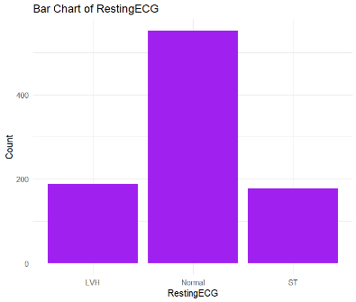
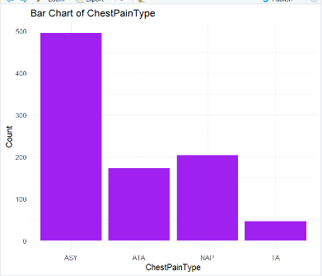
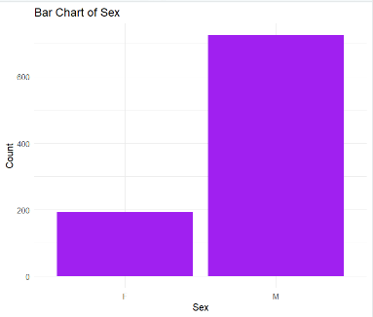
Fig-4: Bar Charts
Bivariate Analysis:
Scatter Plots: Scatter plots revealed relationships between medical indicators. Higher Old peak values tended to align with the presence of heart disease, while Max HR showed a downward trend among patients with heart issues.
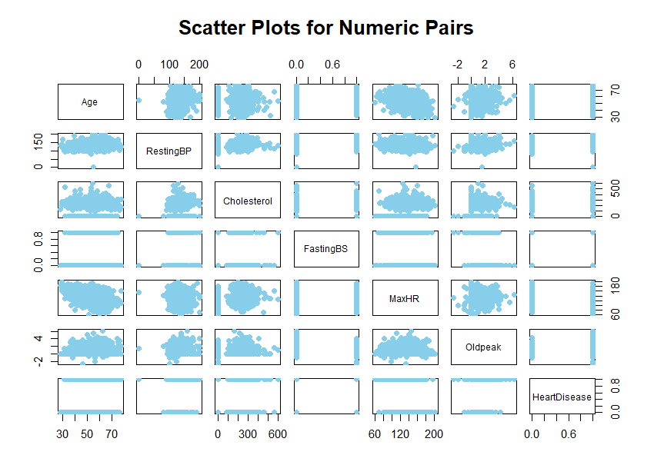
Fig-5: Scatter Plots

Correlation Matrix and Heatmap:
A correlation heatmap showed the strength of relationships between numeric variables. Most correlations were mild, while Age–Max HR and Old peak-Heart Disease showed more noticeable patterns.
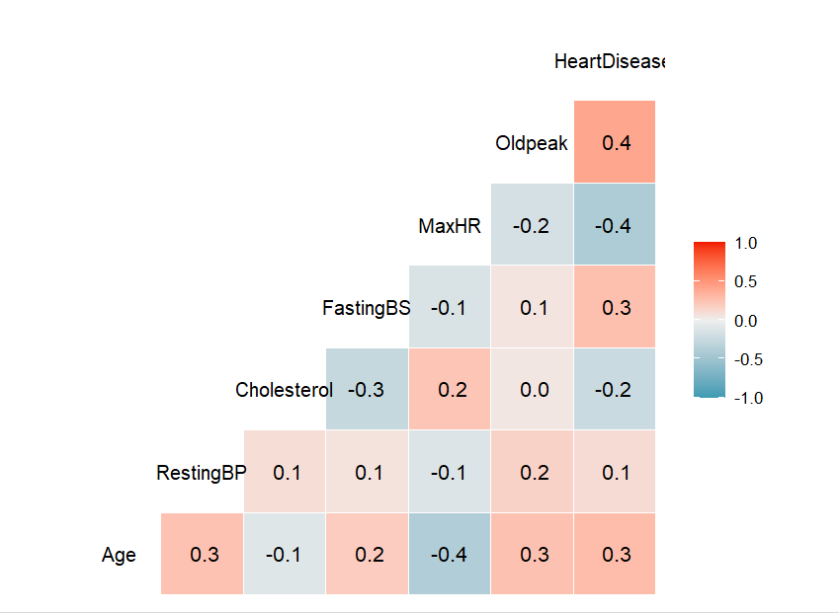
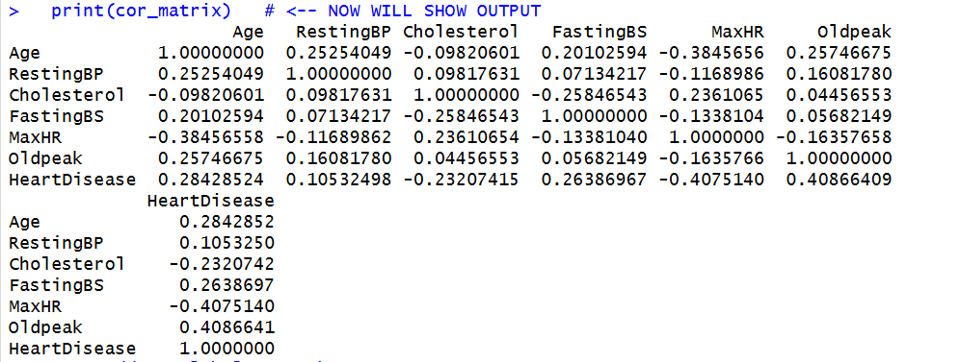
Fig-6: Correlation Matrix and Heatmap
Pair Plot:
Pairwise plots offered a deeper visualization of how multiple variables interact with each other, especially when separated by the Heart Disease label.
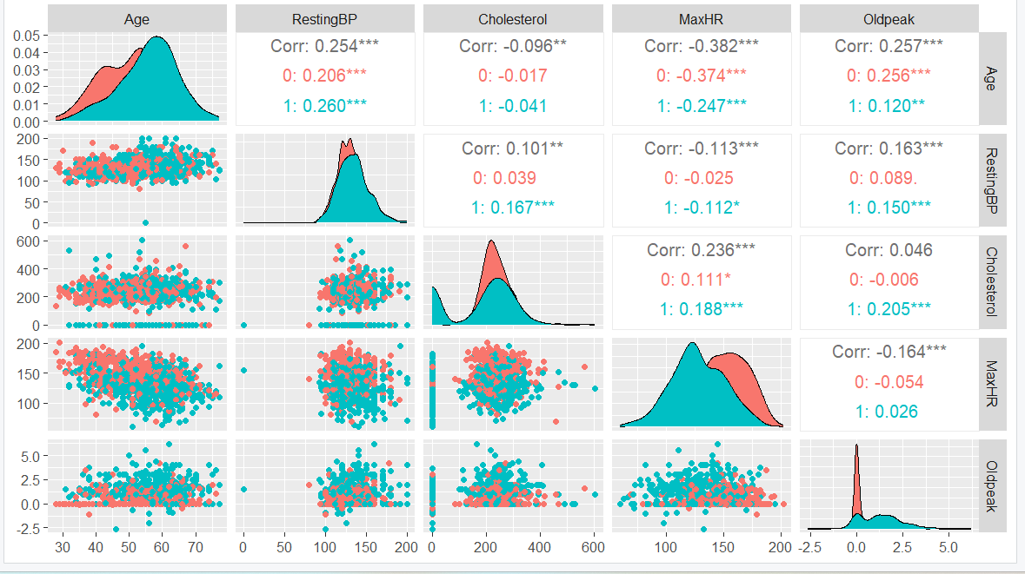
Fig-7: Pair Plot
Boxplots between categorical and numeric features:
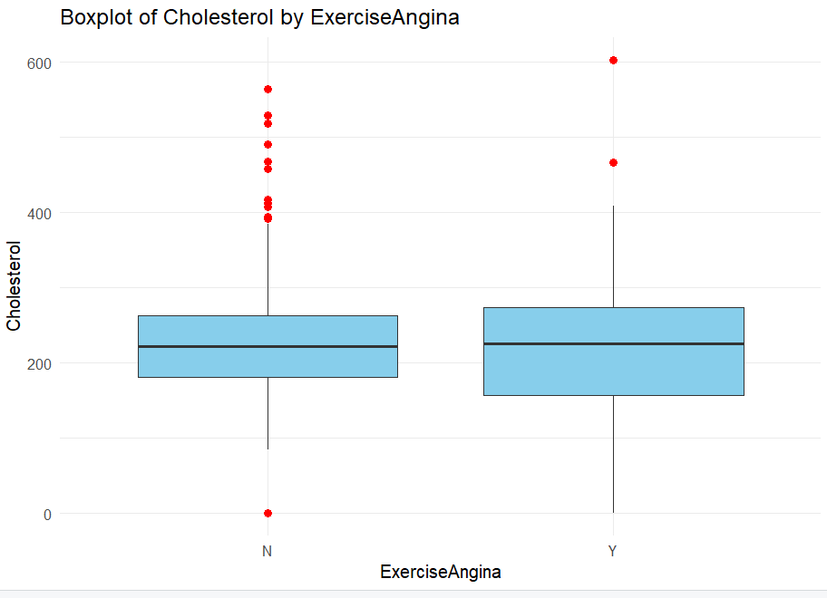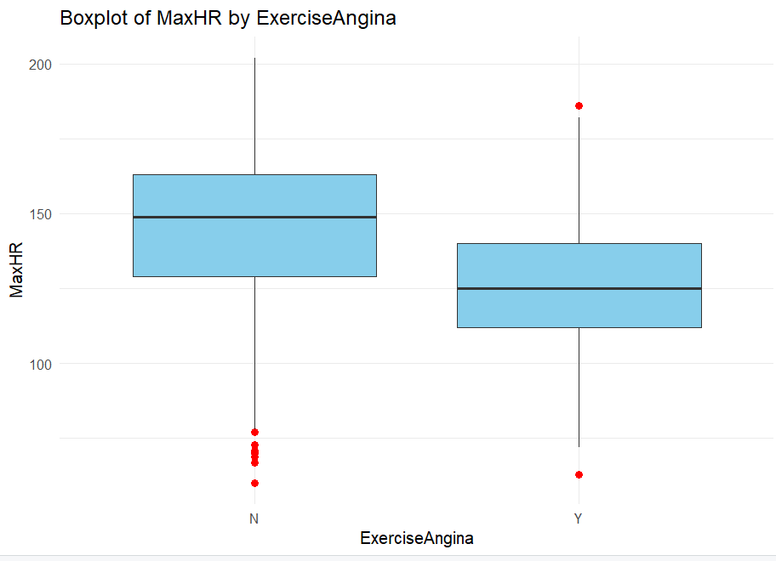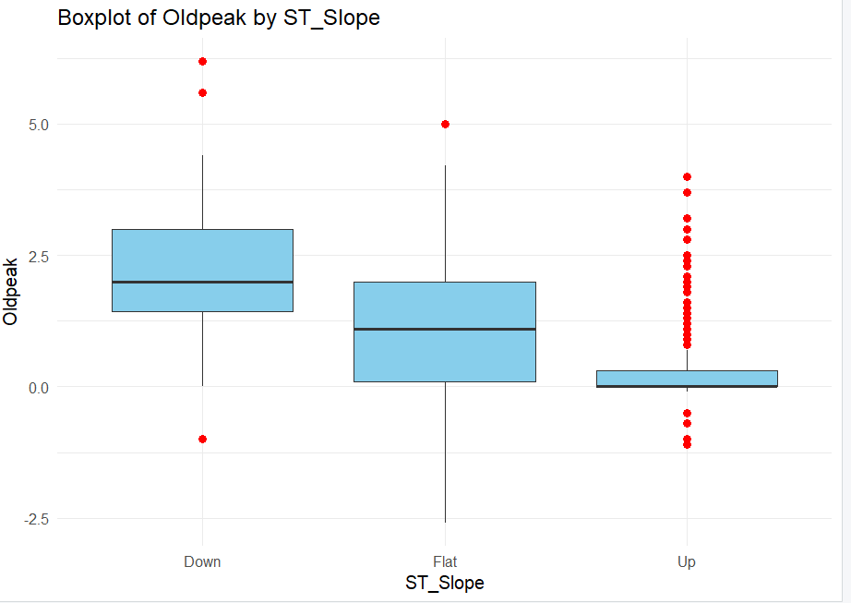
Fig-8: Boxplots between categorical and numeric features

3.Possible Outliers:
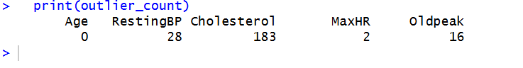
Fig-9: Possible Outliers

Part C: Data Preprocessing:

1.Handling Missing Values:
Because real medical data often contains missing entries, a portion of the dataset was intentionally modified by injecting NA values. Around 0.65% of the entries in this project were set to NA in the following fields:
- Age
- Resting BP
- Cholesterol
- MaxHR
- Oldpeak
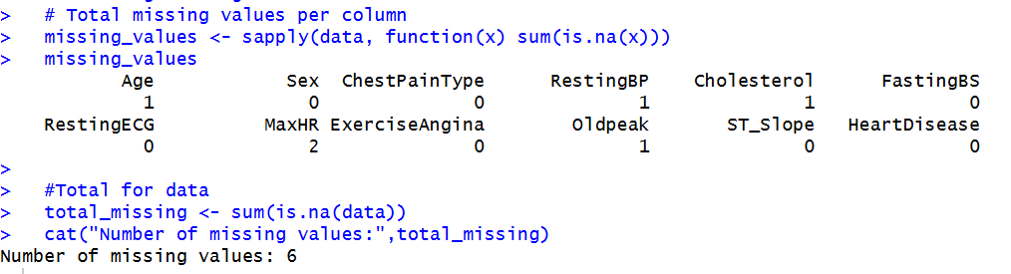
Fig-10: All Missing Values
In our dataset, missing values were detected using is.na() and summary statistics. Instead of imputing the missing values, we applied listwise deletion, meaning rows containing any missing values were removed. This method ensures that the analysis is performed only on complete and reliable data. Since the percentage of missing data was very small, deleting those rows did not significantly affect the dataset size or introduce bias. After deletion, we verified that no missing values remained, and the cleaned dataset was used for further analysis and modeling

2.Handling Outliers:
Outlier Identification
- Only numeric features (excluding binary columns) were considered.
- Outliers were detected using boxplots and the Interquartile Range (IQR) method.
- IQR is calculated as:
IQR=Q3−Q1IQR = Q3 - Q1IQR=Q3−Q1
where Q1Q1Q1 = 25th percentile, Q3Q3Q3 = 75th percentile.
Outlier Handling (Capping / Winsorization)
- Instead of removing outliers, a capping method (Winsorization) was applied to limit extreme values.
- Any value below Q1−1.5×IQRQ1 - 1.5 \times IQRQ1−1.5×IQR was replaced with the lower bound.
- Any value above Q3+1.5×IQRQ3 + 1.5 \times IQRQ3+1.5×IQR was replaced with the upper bound.

3. Data Conversion:
Conversion Method:
- Binary categorical variables (with two unique values) were converted using label encoding, where one category was mapped to 0 and the other to 1. For example:
  - Sex: Male → 1, Female → 0
  - Exercise Angina: Yes → 1, No → 0
- Multi-class categorical variables (with more than two unique values) were transformed using one-hot encoding, which creates separate binary columns for each category. This ensures that no ordinal relationship is falsely implied among categories.
After conversion, all features in the dataset were numeric, making it ready for further preprocessing steps, including normalization and feature selection.

4.Data Transformation:
Data transformation is essential to ensure that numeric features are on a comparable scale and to improve the performance of machine learning algorithms. Additionally, transformation can help reduce skewness in features, making them more suitable for modeling.
Transformation Steps:
- Normalization: All non-binary numeric features were scaled using Min-Max normalization. This transforms each feature to a range between 0 and 1, ensuring that features with larger ranges do not dominate those with smaller ranges.
- Handling Skewness: The skewness of numeric features was evaluated. Highly skewed features were identified to check if log or square root transformations were necessary. In our dataset, Min-Max normalization sufficiently handled the scales, and no further transformation was required.
After transformation, all numeric features are normalized and ready for modeling, ensuring that features contribute equally during training and preventing bias due to scale differences.

5.Data Exploration:
- Variance Thresholding:
  - Features with very low variance provide little information to the model.
  - A variance threshold of 0.01 was applied to remove such features.
  - Only features with sufficient variability were retained for further analysis.
- Mutual Information (Information Gain):
  - Mutual information was calculated to measure the non-linear relationships between each feature and the target variable.
  - Features with higher information gain contribute more to predicting heart disease and were prioritized.
Observations:
- The most important features identified include ST_SlopeUp, ST_SlopeFlat, ChestPainTypeASY, ExerciseAngina, MaxHR, and ChestPainTypeATA.
- These features are strongly associated with the likelihood of heart disease and will be used as key predictors in the modeling stage.
Through variance thresholding and mutual information analysis, the dataset was refined to retain only the most informative features, improving the efficiency and accuracy of predictive modeling.

Summary of Findings and Conclusion
- Data Overview
- The dataset contains 918 observations and 12 features, including both numeric and categorical variables.
- Key numeric features include: Age, RestingBP, Cholesterol, MaxHR, Oldpeak, and FastingBS.
- Categorical features such as Sex, ChestPainType, ST_Slope, and ExerciseAngina were converted to numeric values for modeling.
- Missing Values
- In the dataset some missing values were given manually, which were removed to ensure clean analysis.
- After removal, the dataset retained most of its observations with no missing entries.
- Outliers
- Outliers were detected using boxplots and the IQR method.
- Significant outliers were present in Cholesterol, Oldpeak, MaxHR, and RestingBP.
- These outliers were capped to reduce their impact on analysis while retaining the data distribution.
- Data Conversion
- All categorical features were converted into numeric form:
  - Binary columns (e.g., Sex, ExerciseAngina) were encoded as 0/1.
  - Multi-class features (e.g., ChestPainType, ST_Slope) were one-hot encoded.
- This ensured that all features are numerically compatible for modeling.
- Data Transformation
- Numeric features were normalized using Min-Max scaling to bring them into a consistent range [0,1].
- Binary features were excluded from normalization to preserve their 0/1 encoding.
- Skewness of features like Cholesterol and Oldpeak was checked; no additional log/sqrt transformations were applied as the normalized data were sufficient for modeling.
- Feature Selection
- Correlation analysis showed that some features are highly related, while others had minimal linear association with the target (HeartDisease).
- Variance thresholding was applied to remove low-variance features.
- Mutual information / information gain identified the most important predictors of heart disease:
  - ST_SlopeUp, ST_SlopeFlat, ChestPainTypeASY, ExerciseAngina, MaxHR, ChestPainTypeATA.
- These features were retained for predictive modeling as they have the highest impact on HeartDisease occurrence.
- Data Visualization Insights
- Histograms and boxplots revealed age distribution peaks around 40–60 years and highlighted the spread of numeric features.
- Boxplots between categorical and numeric features showed how features like MaxHR and Oldpeak vary across different chest pain types or ST_Slope categories.
- Correlation heatmaps and scatter plots confirmed patterns between numeric features and indicated which variables might be redundant.

Conclusion
In this study, the Heart Disease Risk Assessment dataset was systematically examined and prepared through a comprehensive data preprocessing pipeline. Missing values were identified and removed to ensure analytical integrity, while outliers were treated using a capping approach to preserve the overall distribution of the data. Categorical variables were encoded into appropriate numerical formats, and normalization techniques were applied to standardize numerical features. Exploratory analyses, including visualizations and feature-selection methods, highlighted key predictors such as ST_Slope, ChestPainType, ExerciseAngina, and MaxHR. These steps collectively enhanced the dataset’s quality, consistency, and suitability for subsequent modeling. Overall, the dataset is now robust, refined, and appropriately structured to support effective and reliable machine-learning-based heart disease prediction in future phases of the project.

